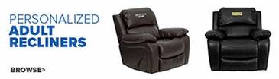 | 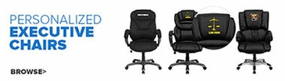
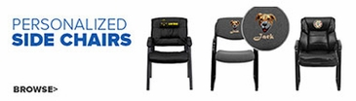 | 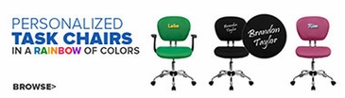
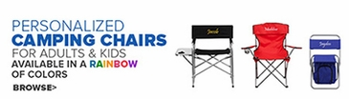 | 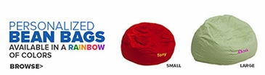
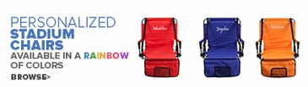 | 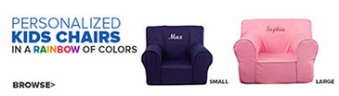
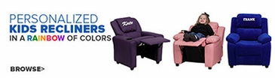 | 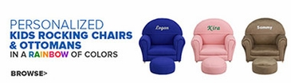
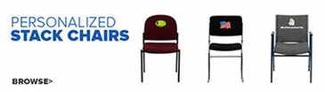 | 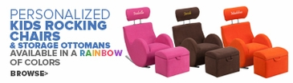
 | 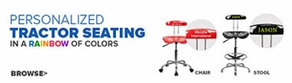
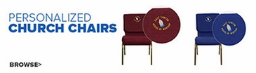 | 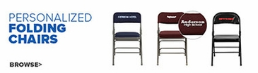
Pro Forms now carries furniture. We can supply your office, kids’ room, or “CAVE”. We have non-customizable and furniture that can be embroidered or vinyl appliques can be added to make it yours.
The possibilities are endless. Quick turn-around after proof is approved.
For more information or to see our complete line.
Phone us at 701-222-1212 or 800-726-4767
Email us at proforms@proformsusa.com
Visit us at www.proformsusa.com

